1. 填空题

1：假设

String s1 = "Welcome to Java";

String s2 = s1;

String s3 = new String("Welcome to Java");

那么下面表达式的结果是什么？

(1) s1 == s2 ____ture________________________

(2) s1 == s3 ____false_______________________

(3) s1.equals(s2) ____true________________________

(4) s2.equals(s3) ____true________________________

(5) s1.compareTo(s2); ____0___________________________

(6) s2.compareTo(s3); ____0___________________________

(7) s1.charAt(0); ____W___________________________

(8) s1.indexOf('j'); ____-1__________________________

(9) s1.indexOf("to"); ____8___________________________

(10) s1.lastIndexOf("o",15) ___9___________________________

(11) s1.substring(3, 11); ____come to_____________________

(12) s1.endsWith("Java") __true_______________________

(13) s1.startsWith("wel"); _____false______________________

(14) " We come ".trim(); ______We come___________________

(15) s1.toUpperCase(); _____ WELCOME TO JAVA___________

(16) s1.replace('o', 'T'); ____ WelcTme tT Java____________

2．如果

StringBuffer s1 = new StringBuffer("Java");

StringBuffer s2 = new StringBuffer("HTML");

假设下列每个语句是独立的，每条语句结束后，写出相应结果

(1) s1.append(" is fun"); s1为__Java is fun_______

(2) s1.append(s2); s1为___ JavaHTML______

(3) s1.insert(2, "is fun"); s1为___Jais funva______

(4) s1.insert(1,s2); s1为___ JHTMLava_________

(5) char c = s1.charAt(2); c为______v_______________

(6) int i = s1.length(); i为______4_______________

(7) s1.deleteCharAt(3); s1为_____Jav_____________

(8) s1.delete(1,3); s1为_____Ja______________

(9) s1.reverse(); s1为_____avaJ____________

(10) s1.replace(1,3, "Computer"); s1为____ JComputera______

(11) String s3 = s1.substring(1,3);

s3为__________av___________，s1为________Java______________

(12) String s4 = s1.substring(2);

S4为________va_____________，s1为________Java_______________

3. 假设StringBuffer s = new StringBuffer("Welcome to JAVA");

将s的内容清空的语句是______s.delete(0,15)_________________。

4.如果

String s1 = "Welcome";  
String s2 = new String("Welcome");  
String s3 = s2.intern();  
String s4 = "Wel" + "come";  
String s5 = "Wel";  
String s6 = "come";  
String s7 = s5 + s6;  
String s8 = "Wel" + new String("come");

那么下面表达式的结果为：

（1）s1 == s2 __false_____

（2）s1 == s3 __true______

（3）s1 == s4 __true______

（4）s1 == s7 __false_____

（5）s1 == s8 __false_____

（6）s1.equals(s2) ___true_____

（7）s1.equals(s3) __ true_____

（8）s1.equals(s4) __ true_____

（9）s1.equals(s7) ___true_____

（10）s1.equals(s8) ___true_____

二、单项选择题

1．可以获取字符串s的最后一个字符的表达式是___C____。

（A）s.length()

（B）s[s.length() - 1]

（C）s.charAt(s.length() - 1)

（D）charAt(s, length(s))

2. 下面程序

class C {

public static void main(String[] args) {

String s = “null”;

if(s == null)

System.out.print(“a”);

else if(s.length() == 0)

System.out.print(“b”);

else

System.out.print(“c”);

}

}

的输出为___C____。

（A）a （B）b

（C）c （D）null

3. 下面的程序

class C {

public static void main(String[] args) {

String s = “Welcome to ”;

concat(s);

System.out.print(s);

}

public static void concat(String s) {

s += “Java”;

}

}

的输出为__A______。

（A）Welcome to （B）Welcome to Java

（C）编译错误 （D）运行时异常

三、编程题

1：编写程序，从控制台或对话框任意输入一个英文字符串，统计字符串中每个英文字母出现的次数并输出到控制台（大小写不敏感）。

package javacourse.ch1;  
import java.util.Scanner;  
  
public class HelloWorld {  
 public static void main(String[] args){  
 System.*out*.println("请输入一段字符");  
 Scanner scanner = new Scanner(System.*in*);  
 String s = scanner.nextLine();  
 char[] chars = s.toCharArray();  
 *countLeters*(chars);  
  
 }  
  
 private static void countLeters(char[] arr){  
 int[] temp = new int[26];  
 for(int i=0;i<temp.length;i++){  
 temp[i]=0;  
 }  
 for(int i=0;i<arr.length;i++){  
 if(arr[i]>='a'&&arr[i]<='z'){  
 temp[arr[i]-'a']++;  
 }  
 if(arr[i]>='A'&&arr[i]<='Z'){  
 temp[arr[i]-'A']++;  
 }  
 }  
 for(int i=0;i<26;i++){  
 if(temp[i]>0)  
 System.*out*.println((char)(i+'a')+"出现了: "+temp[i]+"次");  
 }  
 }  
}

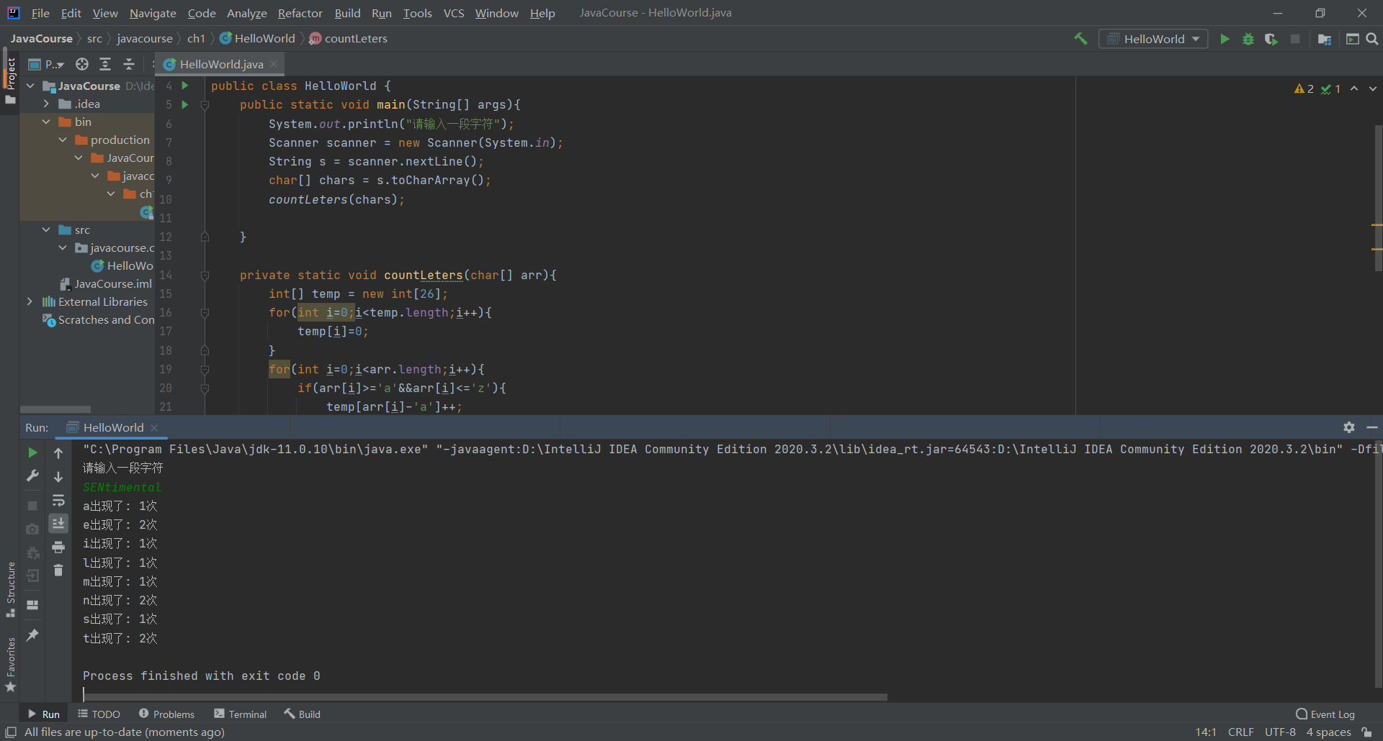

2：假设一个车牌号码由三个大写字母和后面的四个数字组成。编写一个程序. 随机生

成5个不重复的车牌号码。

package javacourse.ch1;  
  
public class HelloWorld {  
 public static void main(String[] args){  
 for(int i=0;i<5;i++){  
 char c1 =(char)(int)(Math.*random*()*26+65);  
 char c2 =(char)(int)(Math.*random*()*26+65);  
 char c3 =(char)(int)(Math.*random*()*26+65);  
 int x1=(int)(Math.*random*()*10);  
 int x2=(int)(Math.*random*()*10);  
 int x3=(int)(Math.*random*()*10);  
 int x4=(int)(Math.*random*()*10);  
 System.*out*.print(c1);  
 System.*out*.print(c2);  
 System.*out*.print(c3);  
 System.*out*.print(x1);  
 System.*out*.print(x2);  
 System.*out*.print(x3);  
 System.*out*.println(x4);  
 }  
  
 }  
}

